Discover coding with HTML and CSS

1. Introduction

Today's project requires you to code your first web page, yeaaah! As a resource, we offer you a very light introduction to HTML / CSS to get you started. This will give you the basics to tackle tomorrow's layout project 😇

2. History and context
What is HTML, what is CSS? In this section, we will see how those two languages are interdependent and how we use them to do front-end development.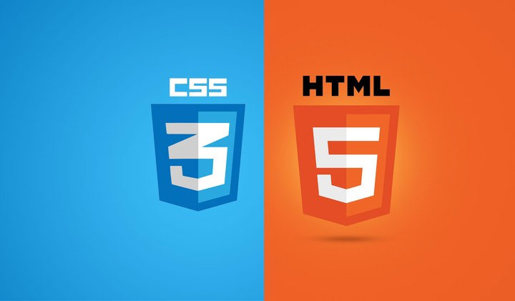

2.1. HTML - the skeleton
Imagine that we want to code this page:
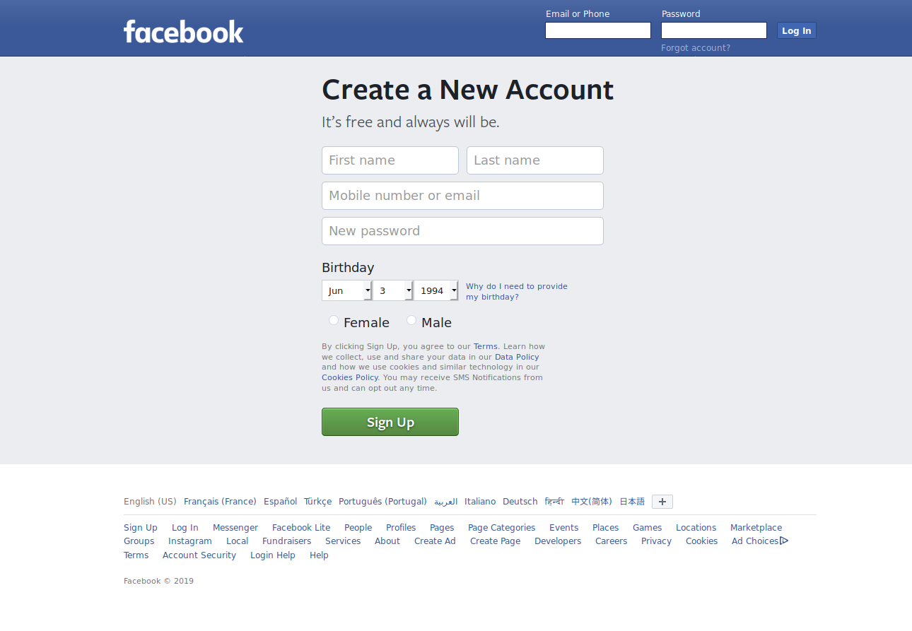
HTML will allow us to set up the structure, and therefore to specify that there will be: a field to fill in your email and password, a logo, and a button to log in. This is what our code would look like:

<header>
<img src="logo.png">
<label>Email of Phone</label>
<input type="email" name="email">
<label>Password</label>
<input type="password" name="password">
<label>Forgot account?</label>
<button>Log In</button>
</header>

Looking at this, even if you've never coded in your life, you can probably guess that it's about a <header>, that there's an <img>, called logo.png (probably an image that should be the logo), that there's input for email and password, and the presence of a button at the end. Tadaam, it's not more complicated than that! For the details, we'll see later.
For now, just remember that HTML allows you to design the skeleton of a page. However, if we were to use it alone, your page would look like this (which is not very funky, let's be honest.) :
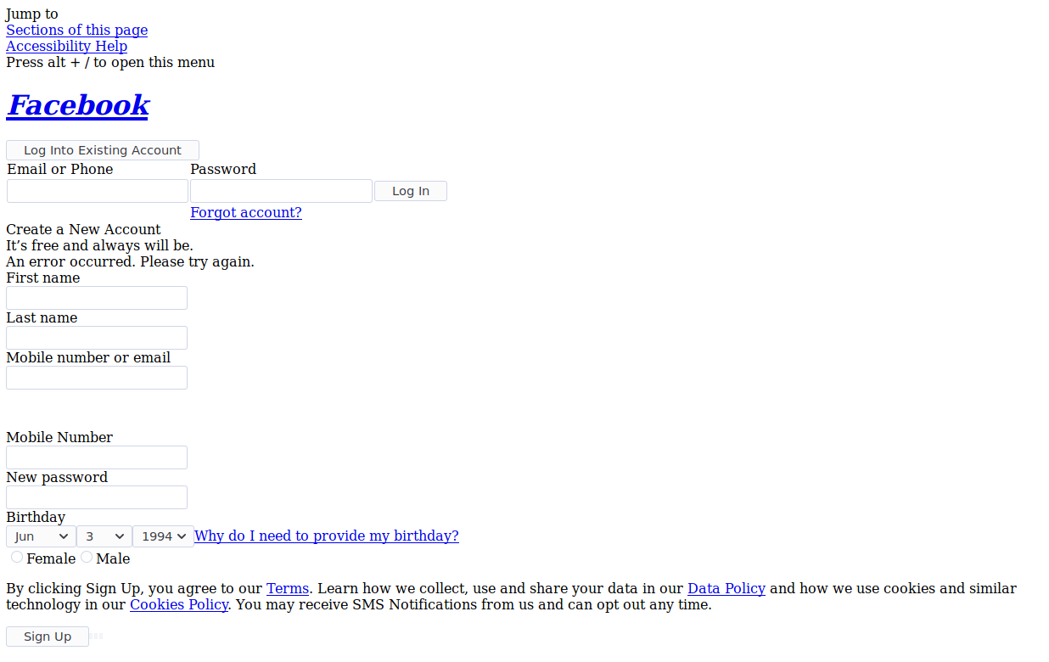

So what's the secret to give elements the right colors, sizes, and formatting? CSS, of course.

2.2. CSS – the dressing
CSS allows you to dress up the skeleton of a page by giving it the shape and layout you want. CSS code looks like this:
p {
text-align: center;
color: red;
}

2.3. Front-end, Back-end
As we mentioned in the previous resource, when you go to a website, you make a request. The servers will then send you HTML/CSS code that your browser (Chrome, Firefox, etc) will interpret. The servers generally refer to the back-end of your site, and the code they send is the front-end.

During this week, we will study the basics of front-end and learn how to make web pages.

📚 INFO
HTML/CSS code is sent by the servers and received by your computer. This code can be read by anything, but we usually use a browser to read and understand it (Chrome, Firefox, Safari, Internet Explorer). Imagine that with the same code, a browser will display it in a different way. It's a bit like correcting a copy of a philosophy exam: you can get a different mark depending on the teacher who is correcting you because he interprets the concepts mentioned in his own way.

By the way, do you know the famous joke that says "Internet Explorer is crap"? That's because version 6 of the infamous browser displayed a lot of HTML and CSS elements not properly.

3. The resource
Les 2 grands avantages du HTML et du CSS ? C'est avant tout un fantastique point d'entrée dans l'univers du code, et il existe une multitude d'excellents cours pour les apprendre. Nous avons la chance d'être amis avec OpenClassrooms qui proposent le meilleur cours en français sur le HTML / CSS : le célèbre Apprenez à créer votre site web avec HTML5 et CSS3 de Mathieu Nebra qui a fait la gloire du SiteDuZéro.

The 2 big advantages of HTML and CSS? First and foremost, it's a fantastic entry point into the world of code, and there are plenty of great courses to learn them. We are lucky enough to be friends with OpenClassrooms who offer the best course in French on HTML / CSS: Mathieu Nebra's well-known class Learn to create your website with HTML5 and CSS3 which made SiteDuZéro famous.
For this lesson, we're going to ask you to skim through Learn how to create your website with HTML5 and CSS3, up to the part The box model.

You can then watch Jake Wright's excellent video Learn CSS in 12 minutes

.4. To go further

To go further, you can continue with Mathieu Nebra's HTML / CSS course, but nothing beats practice: just do the project of the day!

